EXP – 1 Create a simple cloud software application for flight reservation system using any cloud service provider to demonstrate SaaS

Done by: Juhi Surin
Register no. :192525148

Aim:
To develop a cloud-based Flight Reservation System using Zoho Creator (SaaS) that enables users to book airline tickets and automatically calculates the total fare including GST.

Procedure:
- Log in to Zoho Creator and create a new application named Airline Reservation System.
- Create an Airline form and add the required fields for passenger and booking details.
- Configure the Source and Destination dropdown fields with city names.
- Create a workflow to automatically calculate the Total Fare and Grand Total with 18% GST.
- Enter the passenger details and submit the form to save the reservation.
- View the stored booking details and calculated fare in the Airline Report.

Implementation Steps :
Step 1: Log in to Zoho Creator and create a new application named Airline Reservation System.
Step 2: Create an Airline form and add the required fields for passenger and booking details.
Step 3: Configure the Source and Destination fields using dropdown values.
Step 4: Create a workflow to calculate the Total Fare and Grand Total with 18% GST automatically.
Step 5: Enter the passenger details and submit the form to store the reservation.
Step 6: View the reservation details and calculated fare in the Airline Report.

Output:
- Form
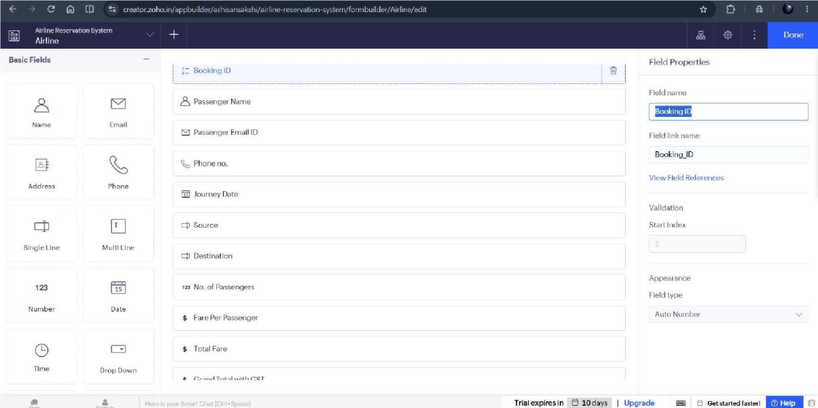

- Workflow
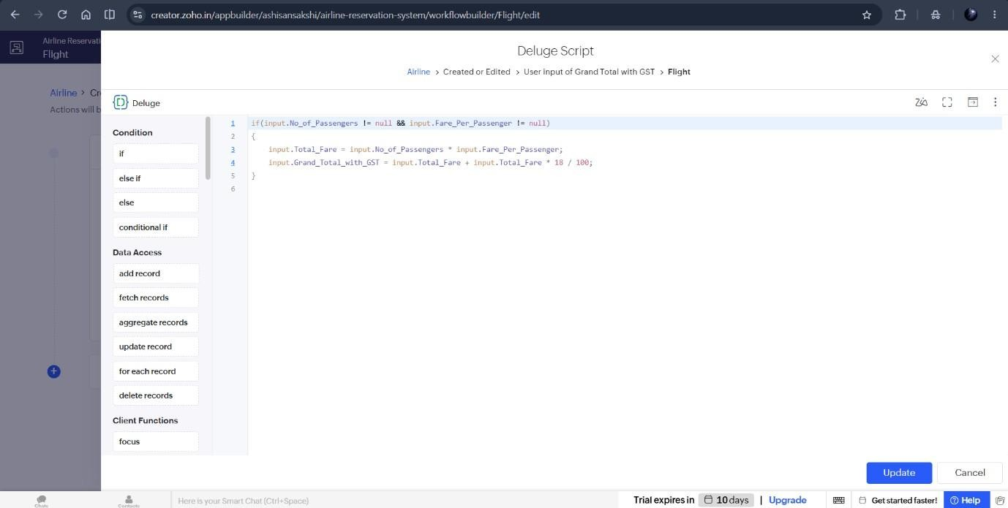

- Report
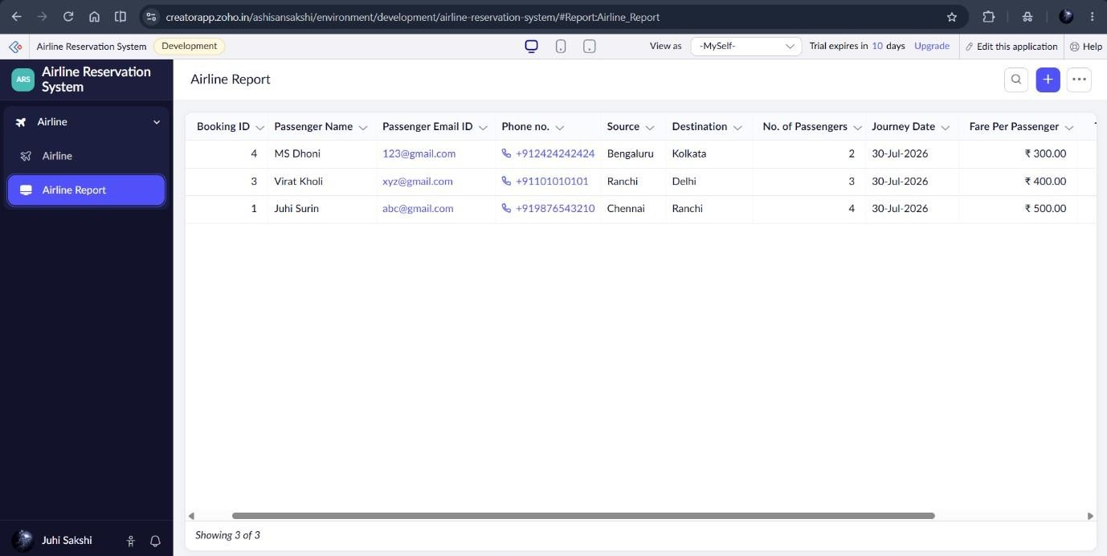

Result:
Thus, the Airline Reservation System was successfully implemented using Zoho Creator.

